**Project Title :- Lead Management System**

**Problem Statement**

Small and medium-sized businesses struggle to manage leads and customer data efficiently. This causes missed opportunities, delayed follow-ups, and poor sales conversion rates.  
My project aims to create a Salesforce-based CRM solution that centralizes customer data, automates lead tracking, prevents duplicates, and provides real-time analytics to improve sales productivity. They face challenges in tracking leads, managing sales opportunities, and following up with customers on time, which leads to lost sales and poor customer satisfaction.

My project aims to build a Salesforce-based Customer Relationship Management (CRM) solution to centralize customer information, automate lead tracking, and provide real-time insights to sales teams. This will help businesses streamline their sales process, improve follow-ups, and increase overall productivity.

**Phase 1: Problem Understanding & Industry Analysis**

**Requirement Gathering:**

* Track lead status (New → Contacted → Qualified → Converted).
* Assign leads automatically/manually to sales reps.
* Prevent duplicate leads.
* Generate lead conversion and revenue reports.
* Notify reps when leads are updated/assigned.

**Stakeholder Responsibilities**

|  |  |
| --- | --- |
| Stakeholder | Responsibilities |
| Admin | Manages setup, roles, data integrity |
| Sales Reps | Create/manage leads, update status, follow-up |
| Sales Manager | Monitors lead progress, approves opportunities, generates reports |
| Customer Service | Handles customer queries, identifies potential leads |

**Business Process Flow:**Lead received → Duplicate check → Lead assigned → Rep contacts lead → Manager reviews → Lead updated/converted → Notification sent.

**Industry Use Case:**Timely follow-ups and automated tracking improve sales efficiency and customer satisfaction.

**Phase 2: Org Setup & Configuration**

**User Setup:**

* Create users: Sales Rep & Sales Manager.
* Assign roles (Manager → Reps) and licenses.
* Set profiles (permissions), OWD (private leads), and sharing rules.
* Configure login hours for reps.

**Deployment:**

* Build & test in Sandbox → deploy to Production using Change Sets.

**Phase 3: Data Modelling & Relationships**

**Objects Used:**

* Standard: Lead, Contact, Account.
* Custom (Optional): Lead Assignment History, Lead Notes/Interactions.

**Key Fields:**

* Lead: Name, Company, Email, Phone, Lead Status, Lead Source.
* Contact: Name, Email, Phone, Account (after conversion).
* Account: Name, Industry, Revenue.

**Record Types & Layouts:**

* Separate record types for B2B & B2C leads.
* Custom page layouts to show lead details, tasks, and activities.
* Compact layout for mobile view.

**Relationships:**

* Lead → Contact → Account → Opportunity flow.
* Lookup used for assignment; master-detail not required.

## **Lead Status Flow :-**

|  |  |  |
| --- | --- | --- |
| Step | Status | Action |
| 1 | New | Lead enters system |
| 2 | Contacted | Rep reaches out to lead |
| 3 | Qualified | Lead shows interest and meets criteria |
| 4 | Converted | Lead becomes customer |

Dia : SFDC Flow Diagram

**Phase 4: Process Automation (Admin)**

**Lead Assignment Rule:**

• Assign leads automatically based on region or round-robin assignment.

**Auto-Response Rule:**

• Send acknowledgement email when a lead is captured.

**Workflow / Flow Examples:**

1. **Task Creation:** Create follow-up task when Lead Status = "New".

2. **Email Notification:** Send email to sales rep when lead is assigned.

3. **Field Update:** Auto-update Lead Rating to "Hot" if annual revenue > X.

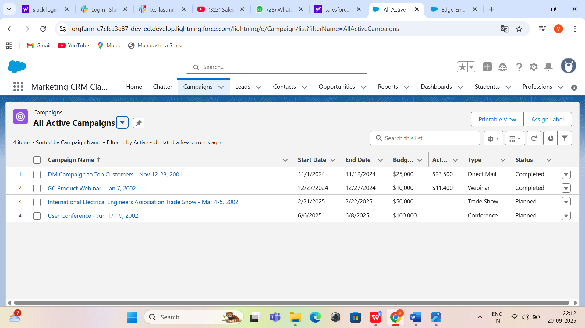

**Approval Process:**

• (Optional) Create approval process for converting high-value leads.

**Phase 5: Apex Programming (If Needed)**

• Apex Trigger: Auto-create Opportunity with default stage when lead is converted.

• Apex Class: Custom logic for lead scoring based on multiple fields.

• Test Classes: Ensure >75% code coverage before deployment.

In this phase, we implement Apex programming to manage advanced automation and integration requirements that cannot be handled by declarative Salesforce tools. An Apex Trigger is created to automatically generate an Opportunity whenever a Lead is converted, and a follow-up Task is created when a Lead is marked as "Hot" to ensure timely action by the sales team. Custom Apex Classes are developed to calculate lead scores based on multiple parameters such as industry, revenue, and activity, and to send email notifications to Sales Managers when a high-value lead is converted. Batch Apex is used to refresh lead scores nightly and to clean up stale leads that have been inactive for over 30 days, while Schedulable. All operations are wrapped with proper error handling, and failed transactions are logged into a custom object for monitoring through an admin dashboard. Finally, comprehensive Test Classes are written to achieve more than 75% code coverage, including bulk and negative scenarios, and using Test.startTest() and Test.stopTest() to verify asynchronous job execution before deployment.

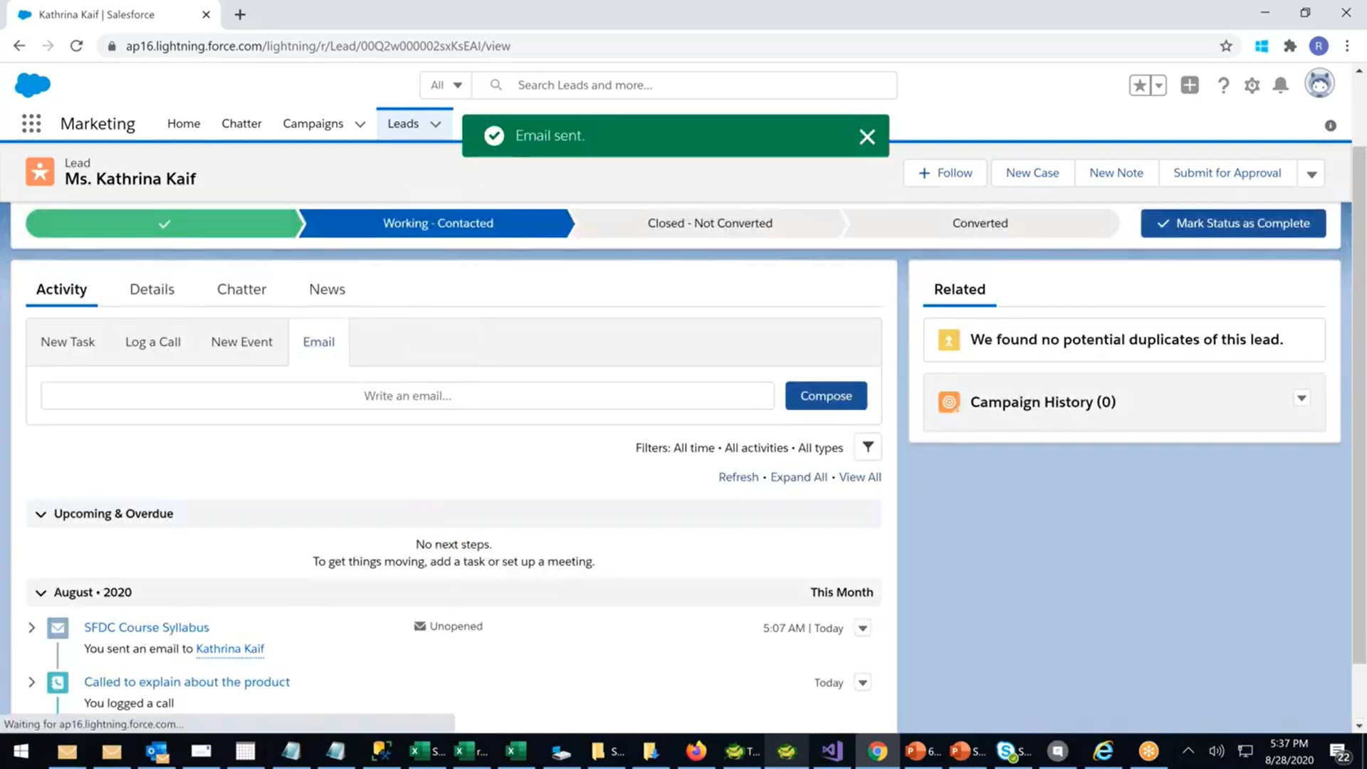

**Phase 6: User Interface Development**

• Create a **Sales App** in Lightning App Builder.

• Add navigation items: Leads, Accounts, Contacts, Opportunities, Reports.

• Create compact layouts (Lead Name, Company, Status, Rating).

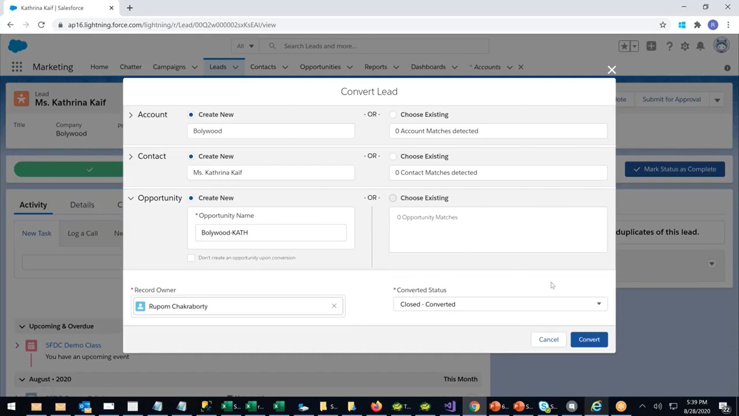

**Phase 7: Integration & External Access**

• Integrate with **Web-to-Lead** form for website inquiries.

• Configure Email-to-Lead capture.

• Use APIs for campaign data sync (optional).

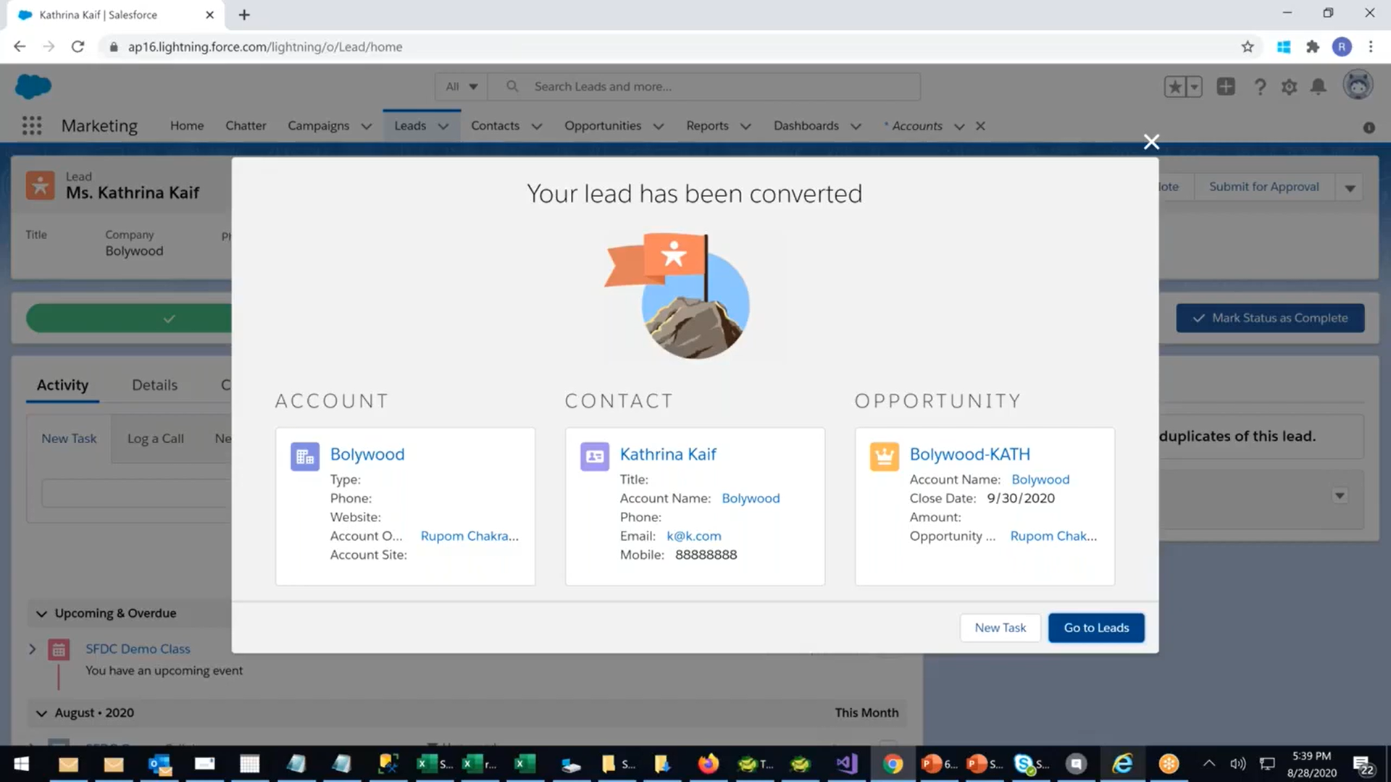

**Phase 8: Data Management & Deployment**

• Import sample lead data using Data Import Wizard.

• Deduplicate using Matching Rules (Email-based).

• Schedule weekly data export for backup.

• Deploy configurations via Change Sets from Sandbox to Production

· **Import Sample Lead Data:** Use the **Data Import Wizard** in Salesforce to upload sample leads in bulk from CSV files. This helps test the system with realistic data.

· **Deduplication:** Apply **Matching Rules** (commonly based on Email or Name) to identify and merge duplicate leads. This ensures your data is clean and avoids repeated entries.

· **Data Validation:** Optionally, check that all required fields are populated and that the data follows your defined rules.

· **Deployment Preparation:** After data is cleaned and tested, your setup is ready to go live or hand over to end users.

.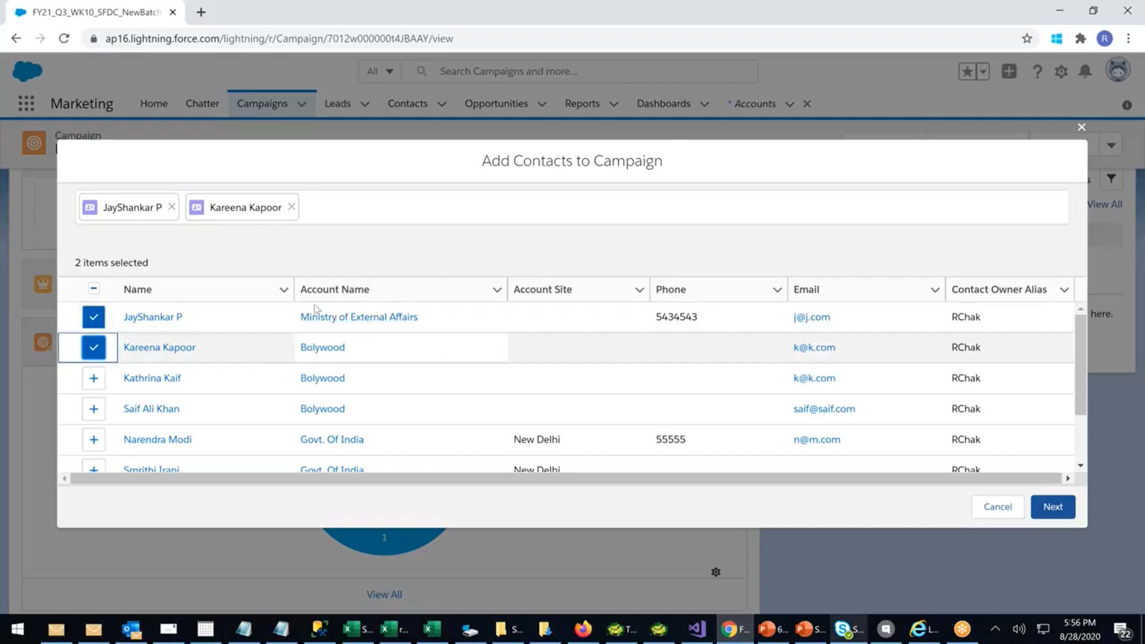

**Phase 9: Reports & Dashboards**

**Reports:**

• Leads by Source

• Leads by Status

• Converted Leads per Sales Rep

• Lead Conversion Rate

**Dashboard Components:**

• Donut Chart → Leads by Source

• Funnel Chart → Lead Pipeline (New → Working → Converted)

• Bar Chart → Conversion per Sales Rep

• Gauge → Average Response Time

**Security & Access Control**

• Field-Level Security: Hide sensitive fields (like Budget) for junior reps.

• Permission Sets: Grant special access to view converted leads.

• Login IP Restrictions: Allow only corporate IPs for added security.

• Enable MFA for all users.

**Deliverables**

• Configured Salesforce Org with custom fields & automation.

• ERD Diagram (Leads → Account/Contact/Opportunity relationships).

• Sample Lead Data CSV for testing.

• Reports & Dashboard screenshots.

• Deployment plan (Sandbox → Production).

• User Training Guide ((how to qualify, convert, and track leads).